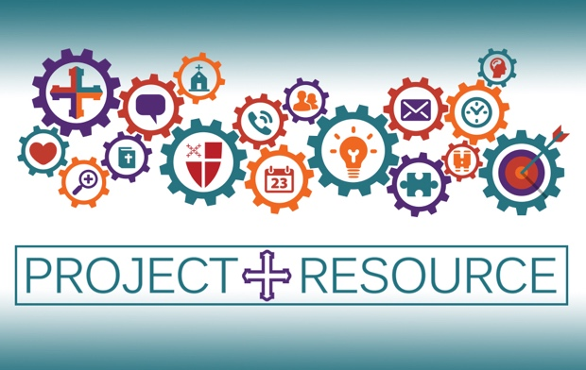
Project Resource: Colorado

There has never been a more critical time to engage in the ministry of Stewardship in the Church.

We are excited to introduce Project Resource to you as Bishop Kym Lucas has partnered with the College for Bishops to bring Project Resource to our diocese for five consecutive Sundays, February 18 to March 17, Online via Zoom; 3:00 to 5:00 pm.

Project Resource teaches culture and systems change around financial development in the worldwide Episcopal Church. Project Resource provides teaching, focus, and adaptable resources to equip clergy and lay leaders to develop their year-round annual stewardship campaigns and plan, ask for, and receive major gifts.

Church teams will complete the course with:
- A year-round stewardship calendar
- A step-by-step plan for implementing a 2023 annual campaign
- Hands-on training on how to make personal invitations
- Understanding generational and individual donor motivations
- Cultural and technological strategies
Project Resource is underwritten by the Office of the Bishop and offered at a 50% discount to our churches in Colorado: the cost for churches in Colorado is $225 for this 5-week training course. (USE DISCOUNT CODE “COLODIO” TO RECEIVE 50% OFF). The cost for a church is the same whether they have a team of 3 or 8. All costs of speakers, materials, and follow-up coaching to participants after the course trainings are covered. Financial Assistance is available by request by emailing Mike Orr at Mike@EpiscopalColorado.org.

